There are more ways than ever to get the most out of your community library.
- All libraries are now offering in-building services. Masks are required when visiting your library.
- Sno-Isle Libraries continues to offer contact-free pickup and return of physical library materials.
- All online services and resources remain available.

In-building
All Sno-Isle Libraries are now open, and you can, once again, join us in-building to browse the stacks, use the computers, and talk with our knowledgeable staff. Masks are required when visiting your library.
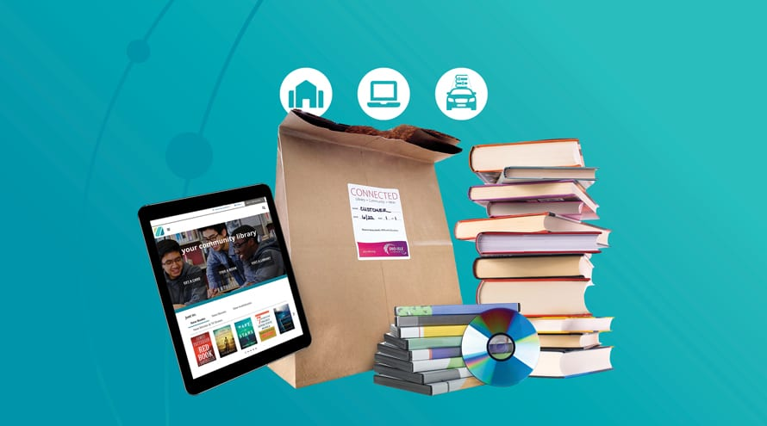

Contact-free Pickup
Sno-Isle Libraries is proud to continue to offer contact-free pickup for our customers' convenience and safety. Simply place your hold as usual then:
- When your items are ready for pickup, you will receive an automated email and/or phone call.
- When you arrive at the library, call the pickup notification number for that library.
- A library staff member will ask for your name and contact information, or library card number.
- A library staff member will check materials out to you and instruct you on how to pick up your materials.
- Take home and enjoy!

